Configuration Guide
Project
PJT03031.R5.PrePay.CD.CRM.Enrollment Alerts: PrePay CRM Configuration
April 2016 Release

Document Information
Document Purpose | PrePay CRM Configuration
Document Owner | Corey Ritts
Business Owner
File Name(s) | PJT03031.R5.PrePay.CD.CRM.Enrollment.Alerts
Stored at | Share Point  Smart Grid Enablement ==➔ SGE Documents ==➔ Release 5 DLA-DPP ==➔ Work In Progress ==➔ Execute ==➔ Configuration Documents ==➔PrePay

Revision History
Version | Date | Author | Comments
1.0 | 02/01/2016 | Corey Ritts | Initial Version
1.1 | 03/29/2016 | Cathy Lindsay | Updated/Corrected Table of Contents, Added roles for alerts
1.2
1.3
1.4
1.5
1.6

Contents

Document Information 2
Revision History 2
1. Business Scenarios 4
1.1.1. - Enrollment Alerts 4
Newly created Code and table configuration: 5
Created Alerts in WebClient 7
Rule Policy ZDLA_ALERTS updated 8

Project: SE – CRM PrePay Interaction Records

1. Business Scenarios

1.1.1. - Enrollment Alerts

Type: Enrollment Alerts Configuration

Logical Component: N/A

Object: CRM Enrollment Alerts

Names: ZPPM_PENDING, ZPPM_COMPLETED, ZPPM_ENROLLED

Solution Manager Sub-Process Path: | CRM - SPRO – Interaction Center WebClient – Additional Functions –Intent Driven Interactions – Service Manager – Define Repository
Document Name: | SE – CRM – PrePay Configuration
Created By: | Corey Ritts |  | Date Created: | 02/01/2016
Change History:
Support Ticket Number (post go-live) | Transport Number | Changed By: | Description of Change: | Change Date:
N/A | C3DK908178

Configuration Logic:

The CSR’s need to be alerted that the customer is a PrePay customer. The alerts will be displayed throughout the lifecycle of the enrollment process. The alerts are created through the table ZTPGM_ALERT_MAP and configured through the IMG activity. The alert Ids also need to be created from CRM WebClient using the user role IC_MANAGER. Once the alerts are created they are added to the rule policy ZDLA_ALERTS. The newly created alerts are listed below.

New Alert Ids created in table ZTPGM_ALERT_MAP;
PPM 01 ZPPM_PENDING
PPM 02 ZPPM_ENROLLED

New ICRule Attribute Ids using SPRO;
ZPPM_PENDING – PPM Enrollment Pending Indicator
ZPPM_COMPLETED – PPM Enrollment Completed Indicator

New Alert Ids created in WebClient and added to the Rule Policy ZDLA_ALERTS;
ZPPM ENROLLMENT COMPLETED
ZPPM PENDING ALERT

CRM roles are assigned to a rule policy group. Within the policy allows the roles to be able to view the alerts.
CRM Roles that will view the Alerts:
ZCRM7_BRC CSR III B. Role - BRC Switch
ZCRM7_PRM CSR III B. Role - PRM Switch
ZCRM7_TEAM CRM 7.0 Functional Team Role
ZIC_BCOP Business Ctr Bus. Role (7)
ZIC_BKOF Customer Billing Bus. Role (4)
ZIC_CSR1 CSR I Business Role (1)
ZIC_CSR2 CSR II Business Role (2)
ZIC_CSR3 CSR III Business Role (3)
ZIC_CSRX Outsource CSR Business Role-10
ZIC_EAM EAM Business Role (6)
ZIC_RVRC Revenue Recovery Bus. Role (5)
ZIC_TRAINING Training Dept Bus. Role (0)
ZIC_VCC VCC Mgmt Bus. Role (9)

Newly created Code and table configuration:
T-Code SM30 for table ZTPGM_ALERT_MAP
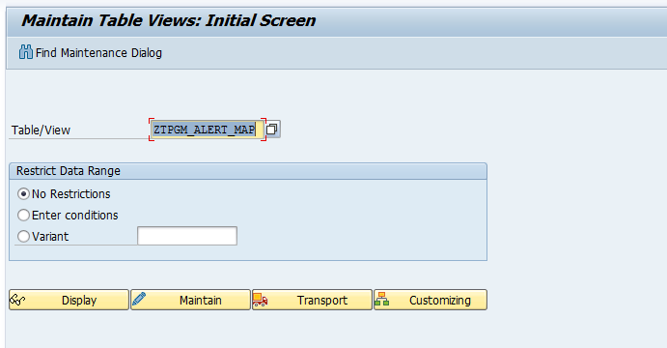
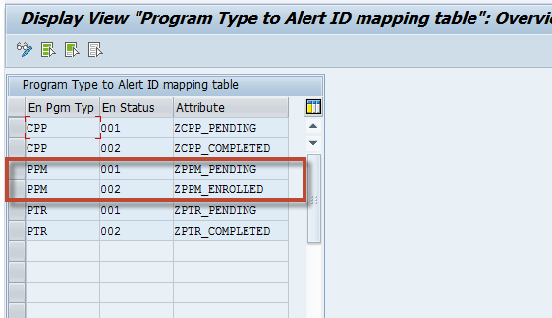

Create Attributes for Alerts
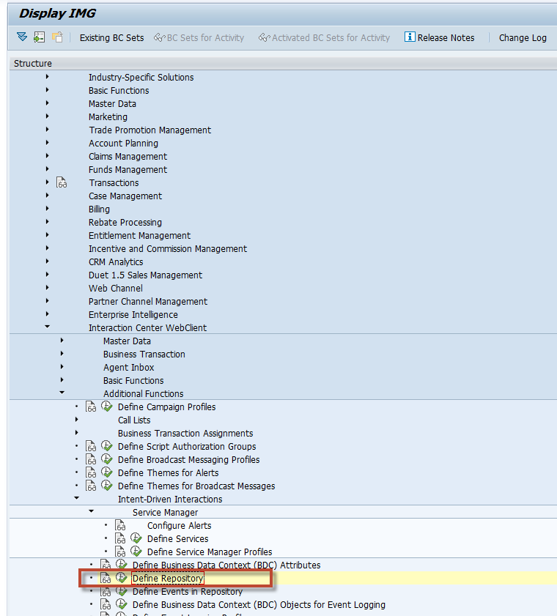

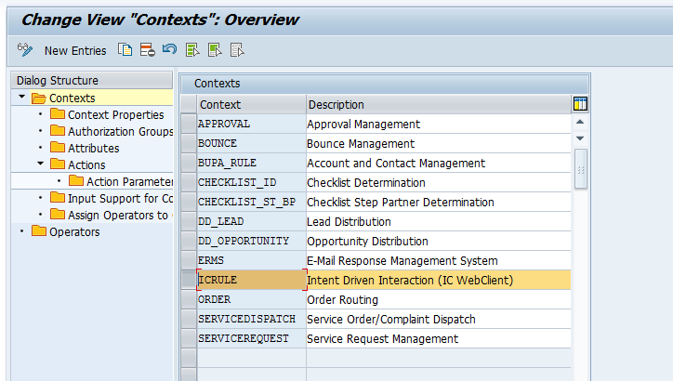
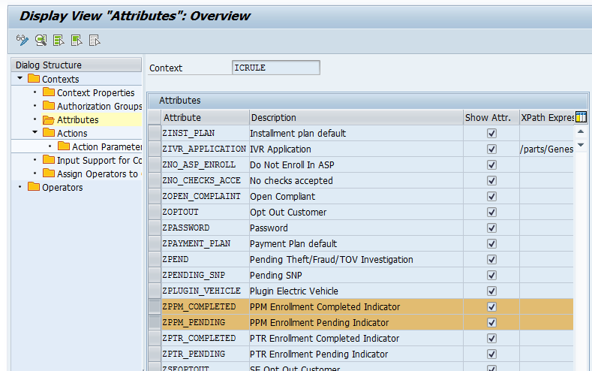

Created Alerts in WebClient
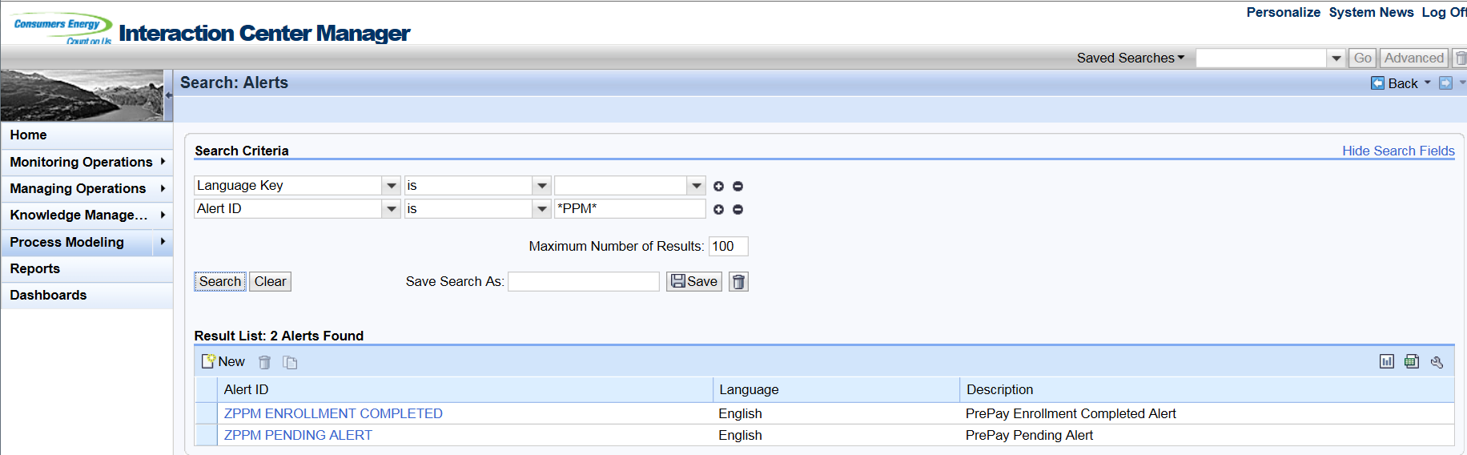

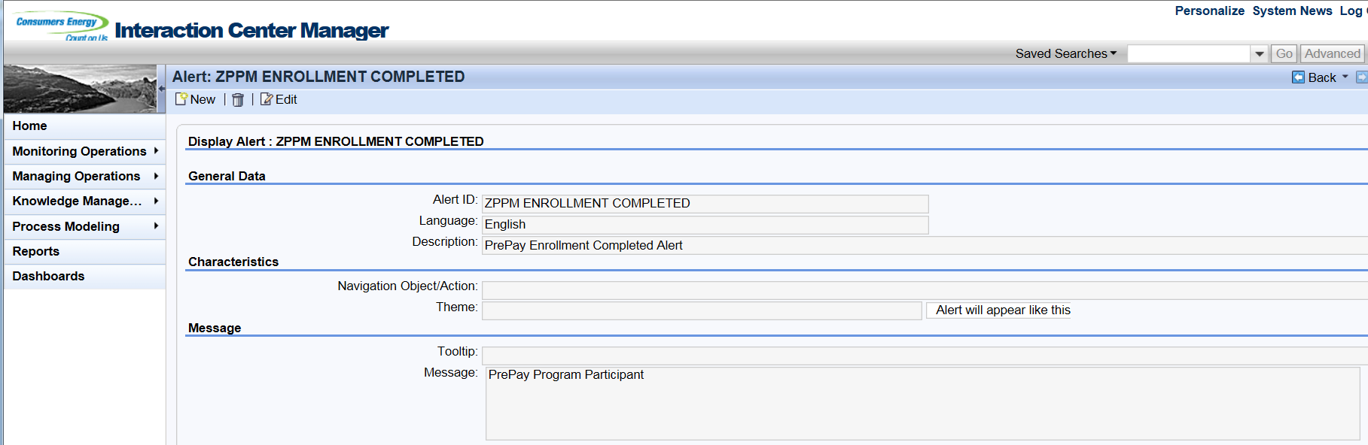

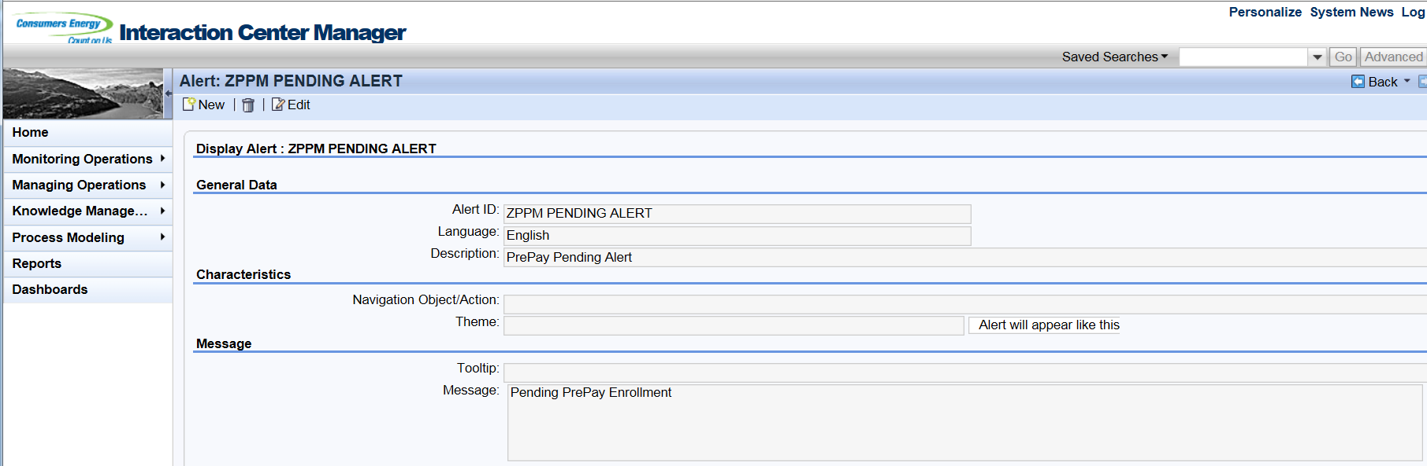

Rule Policy ZDLA_ALERTS updated
